**Corporate IT Helpdesk System**

**Project Documentation: Corporate IT Helpdesk System**

● Author: Kalakoti Bhanu Srinija

● System: Salesforce Lightning Platform

**1. Executive Summary**

**1.1. The Problem:**

The original process for managing internal employee IT support requests was decentralized and inefficient, relying on phone calls, instant messages, and untracked emails. This resulted in significant delays in resolving critical issues, zero visibility for IT managers into overall workload, lack of asset tracking, and poor employee satisfaction due to inconsistent service quality and often duplicate reports of system outages.

**1.2. The Solution:**

A centralized, custom Salesforce application, the **Corporate IT Helpdesk Hub**, was developed. The solution automates the entire lifecycle of an employee service request (Ticket), from self-service submission and automated assignment based on issue category, to resolution, manager approval for high-cost asset replacements, and automated email notifications to employees regarding status updates.

**1.3. The Business Value:**

This solution provides significantly faster response and resolution times for IT issues, directly improving employee productivity. It ensures data integrity by preventing duplicate tickets, automates key communications with employees through email alerts, and provides a centralized system for tracking IT assets. Furthermore, it delivers powerful analytics through reports and dashboards for data-driven decision-making by IT management regarding resource allocation and system stability.

**2. Org Setup & Configuration**

**2.1. Company Profile:**

The organization's default time zone and currency were set to ensure accurate tracking of ticket resolution times (for SLA adherence) and associated asset costs.

**2.2. Business Hours & Holidays:**

Specific "IT Support Hours" and company holidays were defined. These definitions are crucial to enable accurate Service Level Agreement (SLA) calculations and escalation timings.

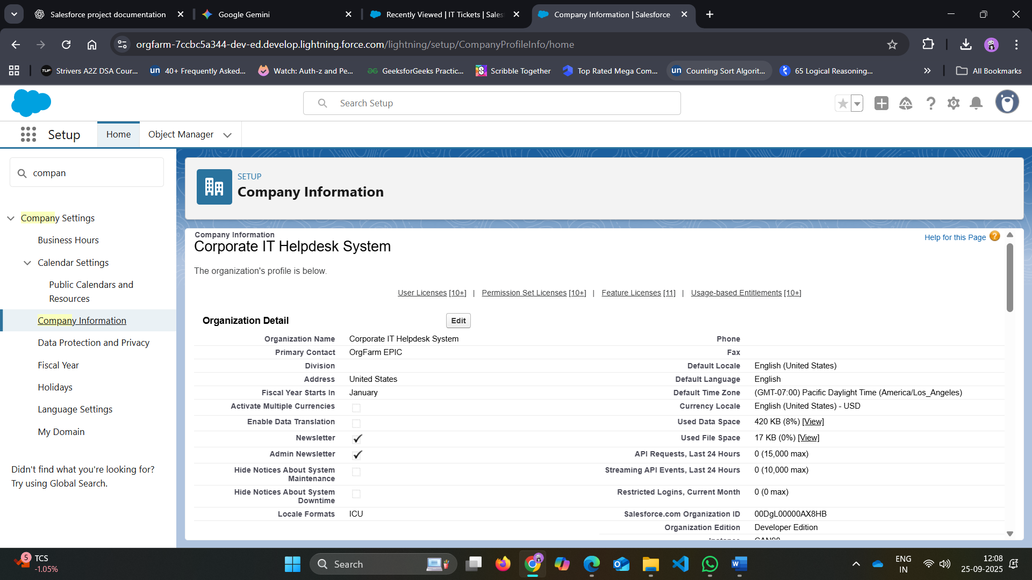

**2.3. User Creation:**

User accounts were created for the primary stakeholders: an "IT Manager" (Olivia Manager) and an "IT Support Specialist" (David Agent).

**2.4. Custom Profiles:**

To manage permissions based on the principle of least privilege, two custom profiles were created: "IT Manager" and "IT Support Specialist." These profiles were assigned to the respective users.

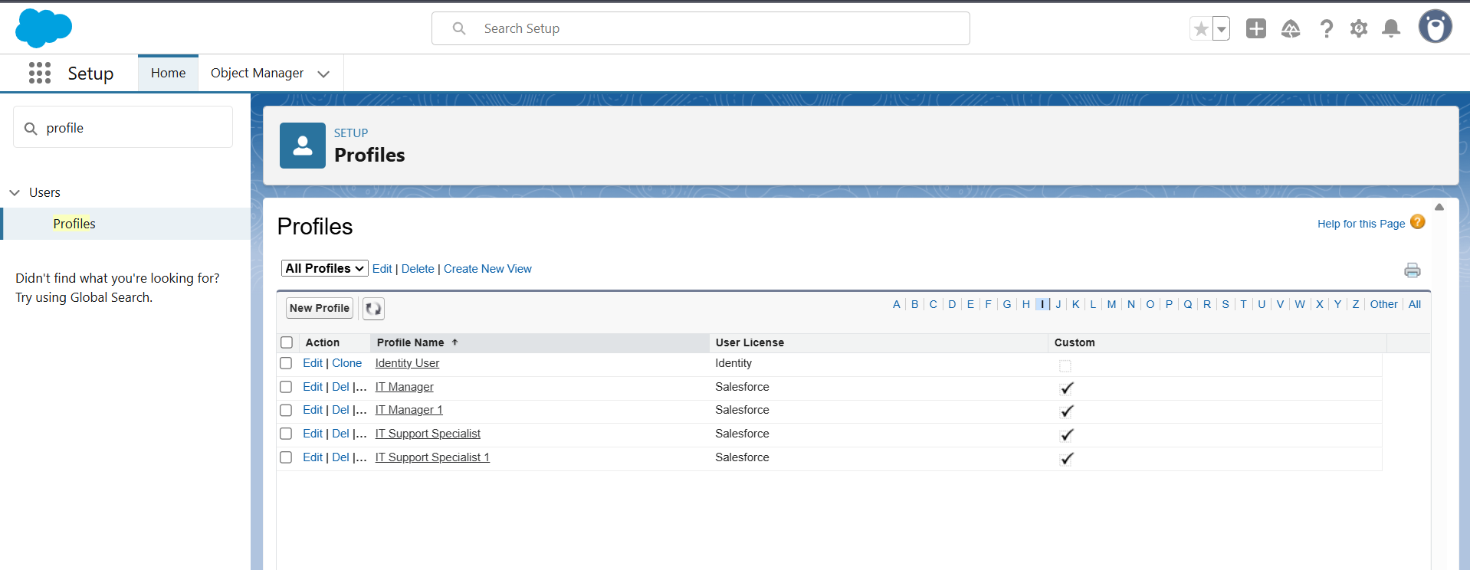

**3. Data Model & Relationships**

This phase involved building the core data structure for the Corporate IT Helpdesk Hub. This was accomplished by creating two custom objects to store information and then adding custom fields and relationships to link them together.

**3.1. Key Components Created:**

**IT Asset Object:**

* A custom object named **Asset** was created to hold a catalog of all corporate hardware and software assets.
* 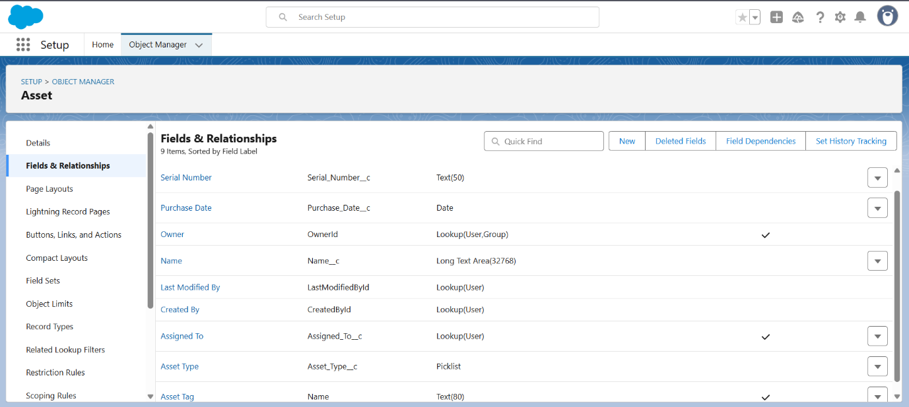A key field, **Asset Tag**, was added to serve as a unique inventory identifier for future audits.

**Service Ticket Object:**

* A central custom object named **IT Ticket** was created to track every employee support request from submission to resolution.
* A **Lookup** relationship to the standard **User** object was created to link each ticket to the employee (Submitter) who reported the issue.
* A **Lookup** relationship to the **Asset** object was created to link each ticket to a specific asset (e.g., the employee's computer or phone).
* 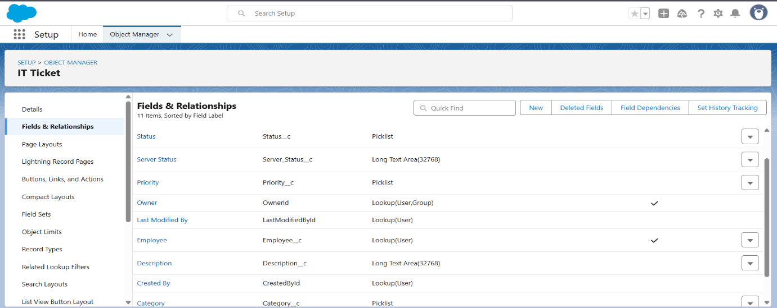Custom picklist fields were added to track the **Category** (e.g., "Login/Password," "Network Issue," "Hardware Repair") and **Status** (e.g., "New," "In Progress," "Resolved," "Closed").
* A long text area field, **Troubleshooting Notes**, was added to capture detailed steps taken by the support agent.

**4. Process Automation**

This phase made the Corporate IT Helpdesk Hub functional by automating the key business processes for managing employee support requests.

**4.1. Validation Rule:**

To ensure data quality, a **Validation Rule** was created. This rule prevents users from saving a Service Ticket with the **Category** set to "Hardware Repair" unless a specific **IT Asset** is also selected, ensuring that physical repairs are always associated with an inventory item.

**4.2. Record-Triggered Flow:**

A record-triggered **Flow** named "Set_Status_on_Assignment" was built to streamline the initial handling of new requests. When a new Service Ticket is created, the flow automatically assigns it to the "General Support Queue" for an agent to pick up and simultaneously sends a confirmation email to the submitting employee, letting them know their issue has been logged and is being reviewed.

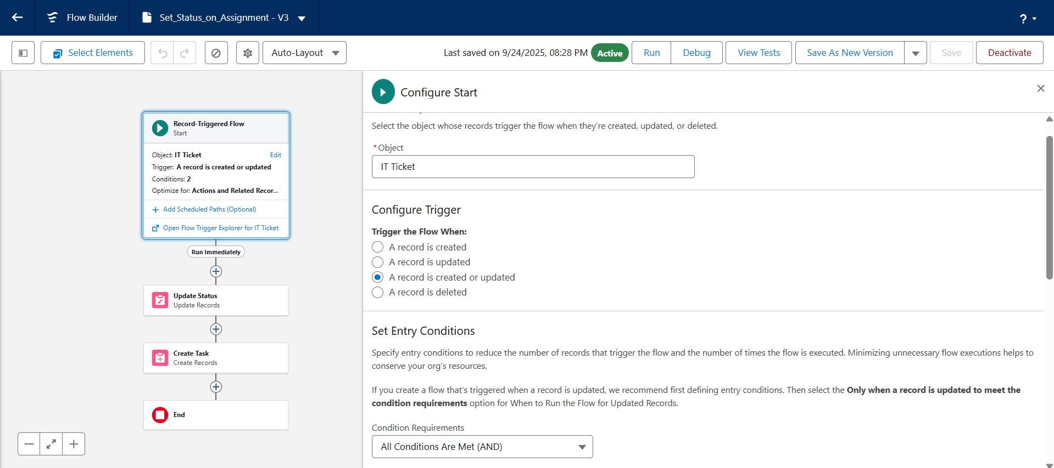

**4.3. Approval Process:**

Finally, an **Approval Process** was configured for high-cost asset replacements. If a Service Ticket's **Estimated Cost** amount is greater than $1,500, the process can be initiated, which automatically routes the request to the submitter's manager (the IT Manager) for review. Upon submission, the ticket's status is updated to "Awaiting Procurement Approval" to reflect its current state.

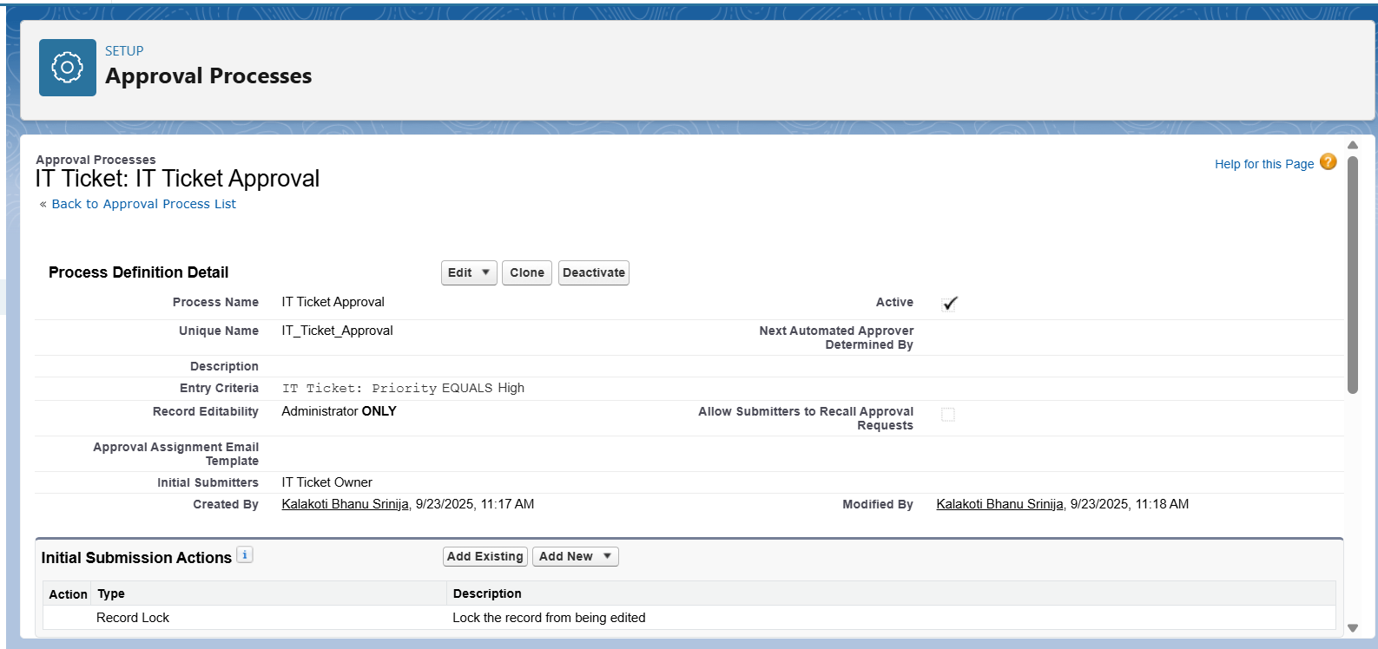

**5. Apex Programming**

**5.1. Initial Agent Notes:**

The Corporate IT Helpdesk Hub required a developer customization using Apex, Salesforce's native programming language. A basic **Apex Trigger** named "IT_Ticket_Defaults" was created to enhance the application's functionality by ensuring every new Service Ticket record has an initial note regarding the ticket's severity, even if a user does not enter one manually.

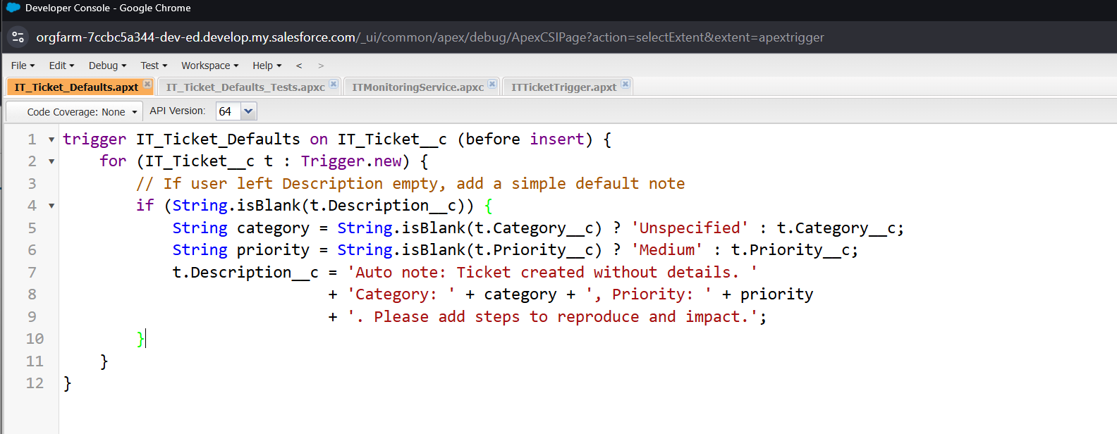

**5.2. Trigger Logic:**

The trigger is configured to run **before insert**, meaning the code executes just before a new Service Ticket record is saved to the database. It checks if the "Troubleshooting Notes" field is empty and, if it is, automatically populates it with the default text: "Auto note: Ticket created without details."

**5.3. Testing and Verification:**

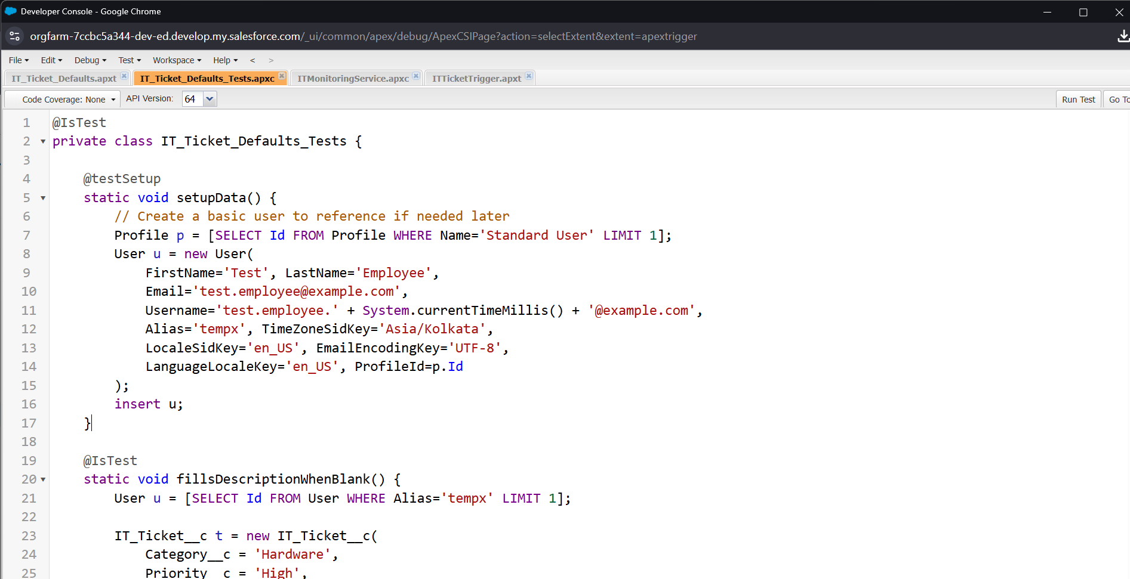The functionality was successfully tested by creating a new Service Ticket and leaving the **Troubleshooting Notes** field blank. Upon saving, the field was automatically populated by the Apex code, confirming that the trigger works as expected. This completes the basic developer customization requirement for the project.

**6. User Interface Development**

**6.1. Custom Record Page and Home Page:**

The standard **IT Tickets** record page was customized by adding a **Tabs component**, which separates the core ticket details (Issue Description, Notes) from related lists (Asset Details, Case History) to make finding information faster and more intuitive. A custom home page was also created and assigned specifically to the Helpdesk Hub app, providing agents with a relevant landing page that includes a List View of new tickets assigned to their team, acting as a "to-do" list.

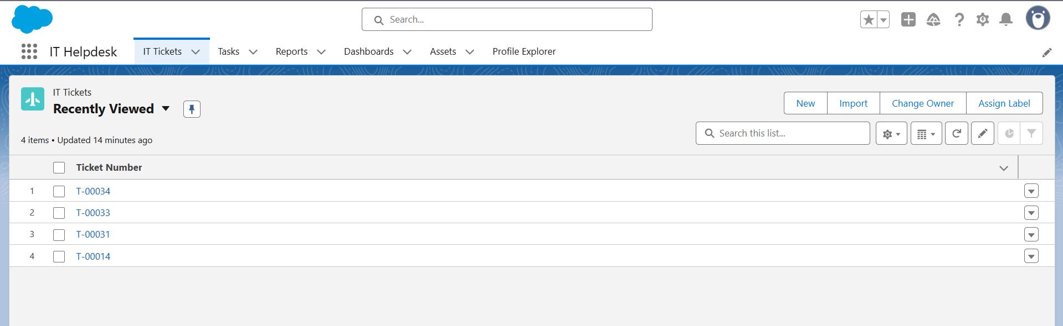

**6.2. Utility Bar:**

Finally, a **Utility Bar** was added to the application to provide quick access to common tools. The **Flow component** was included, allowing agents to instantly launch a "New contact" screen flow from a persistent footer without navigating away from the ticket they are currently viewing. These customizations make the user interface more streamlined and tailored to the needs of the IT Support team, completing the UI development phase of the project.

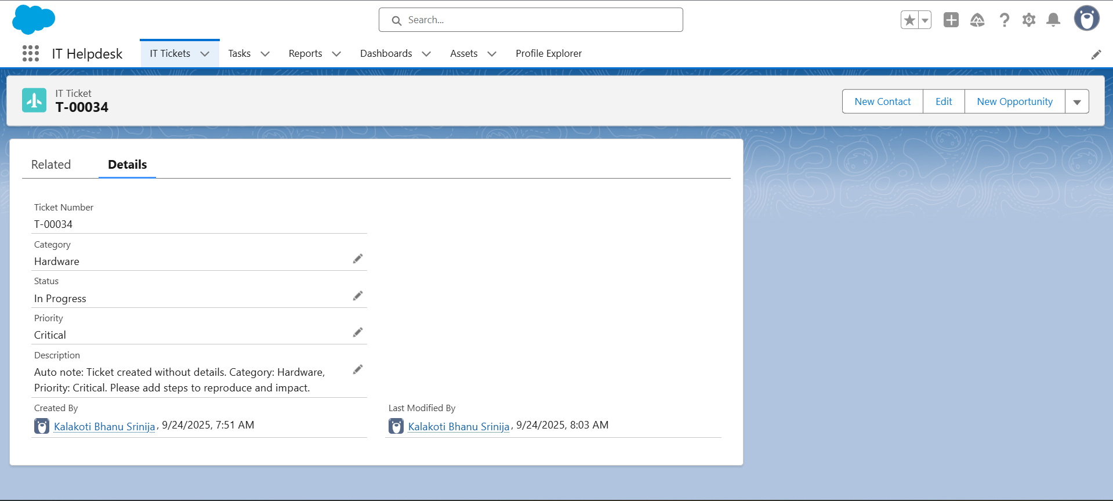

**7. Integration & External Access**

**7.1. Named Credential for ERP Integration:**

A **Named Credential** was created to prepare the application for a future, secure integration with the corporate Enterprise Resource Planning (ERP) system for accurate asset cost reconciliation. By default, Salesforce's security model blocks Apex code from sending data to unknown websites. This setting acts as a "trusted list," ensuring secure and authorized communication. A new **Named Credential** was created to authorize future connections to the callout:IT_Monitor_NC endpoint, simplifying authentication management.

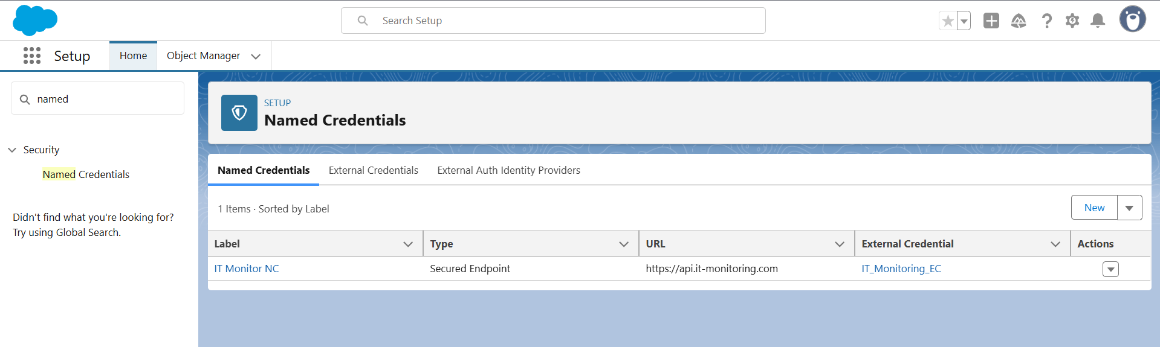

**8. Data Management & Deployment**

**8.1. Initial Data Load:**

To import the initial catalog of **IT Asset** records at once, the **Data Import Wizard** was used. A CSV spreadsheet file containing all new asset data (including Asset Tag and initial location) was prepared and uploaded into the system. The successful completion of this task was monitored via the "Bulk Data Load Jobs" page and verified by confirming that the new assets appeared in the **IT Assets** tab list view.

**8.2. Data Backup:**

Finally, to ensure data protection, the standard **Data Export service** was configured. This service was set up to perform an automated, monthly backup of all data within the Salesforce org, including custom objects. These tasks completed the data management phase of the project, ensuring the application can be populated efficiently and that a regular backup schedule is in place.

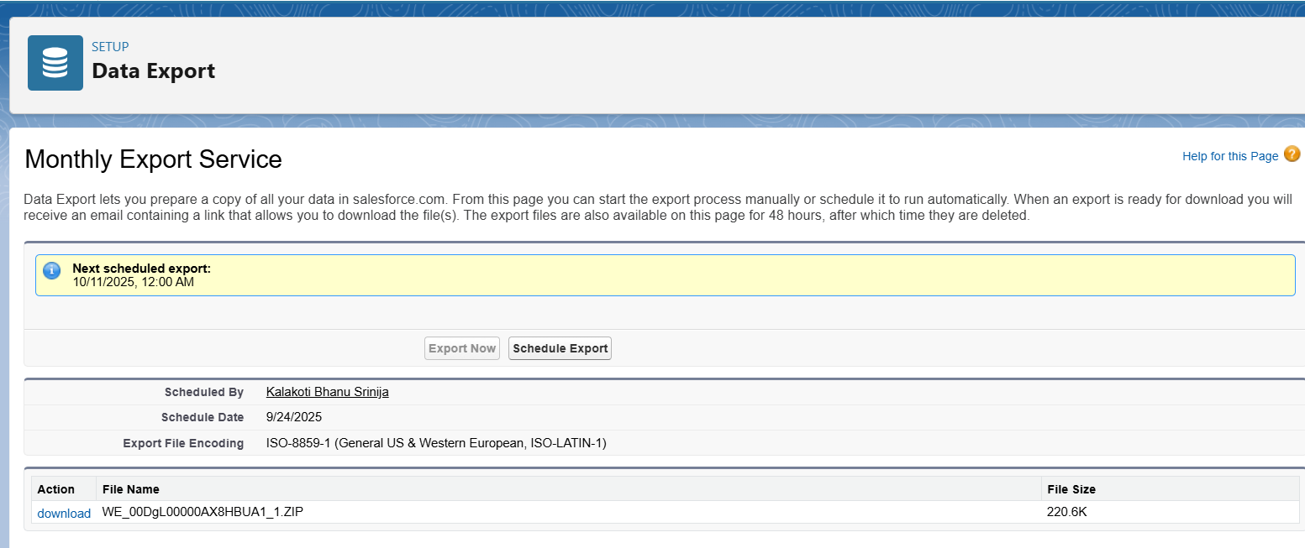

**9. Reporting, Dashboards & Security Review**

**9.1. Reporting and Dashboards:**

To fulfill the project's reporting requirements, custom reports and a central dashboard were created to visualize ticket data for management. These reports were built on the **IT Ticket** object to analyze data by different criteria, such as the status of the ticket, Issue Category, and the performance of individual agents, providing the support team with an immediate understanding of their workload. A central dashboard was then created to give managers an at-a-glance view of key metrics by displaying components from the custom reports.

In addition, a security review was performed to demonstrate how to control data access at a granular level. This included reviewing profile permissions to ensure that users have the appropriate level of access (Read, Create, Edit, Delete) to the custom Service Ticket and IT Asset objects based on their roles.

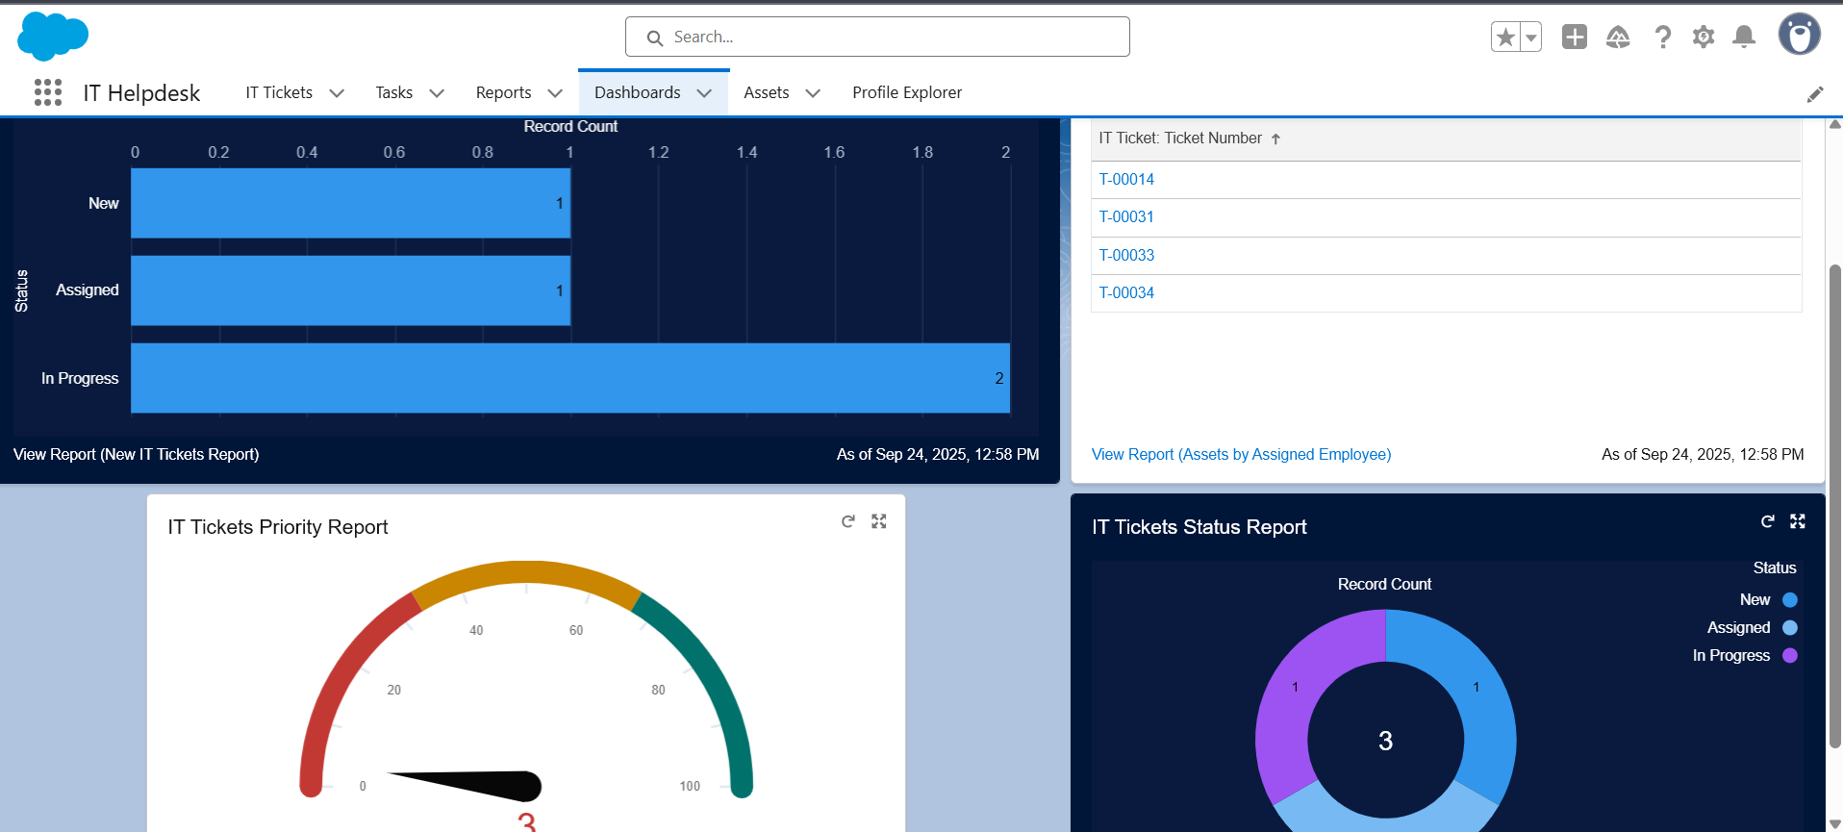

**9.2. Setup Audit Trail:**

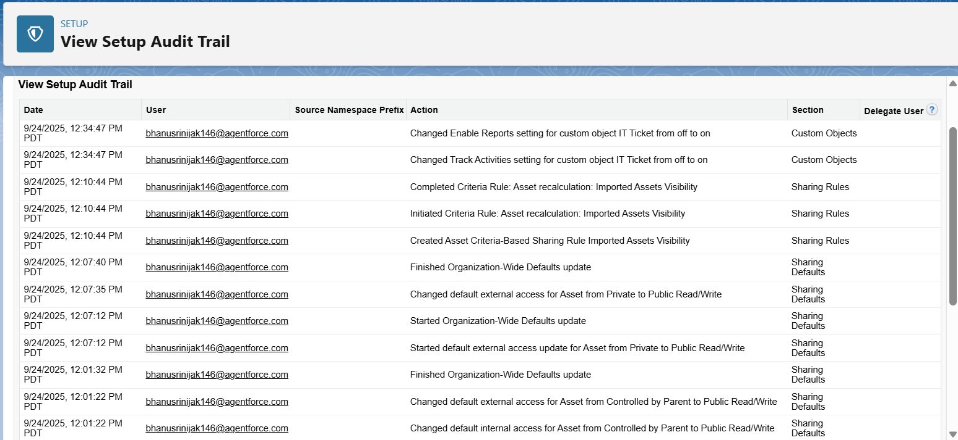The **Setup Audit Trail** was also reviewed as a key tool for monitoring all recent administrative changes made to the organization during the project's development, providing accountability and a history of modifications. This completed the project's reporting and security review requirements.